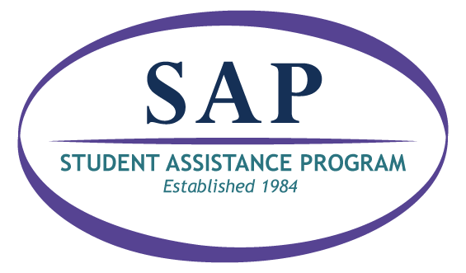
SAP is here to help

What is SAP?
The Student Assistance Program (SAP) helps students who may need extra support to be successful at school. SAP is a caring group of staff who work with families to overcome challenges.

Why was my child referred?
Referrals are made when someone is concerned about a student. Any student who needs extra support in school can be referred to SAP. Anyone can make a referral to SAP including teachers, school staff, and parents.

What happens after my child is referred?
You play an important role in the SAP process and your permission is required. The SAP team will collect information and talk with you about how they can support your child. A team member will also meet with your child. The team will work with you to create a plan to help your child get the support they need to succeed.

SAP Team
The SAP team includes school staff and staff from community agencies that work together to support your child.

{Customize this section to include your SAP team members. Consider adding referral information or link to your website}

Overview of the Pennsylvania SAP Process


Referral- Anyone can refer a student to SAP when they are concerned about a student’s behavior
Data Collection- The team gathers objective information and data to inform their decision-making process. Parent permission is required to continue the SAP process.
Action Planning- A plan is developed to assist the student in accessing recommended school and/or community supports. The team may utilize community-based services which may include a drug and alcohol and/or mental health screening/assessment.
Follow-Up- The team monitors progress towards goals and checks-in with the family, student, and referral source. The plan is adjusted as needed.

